

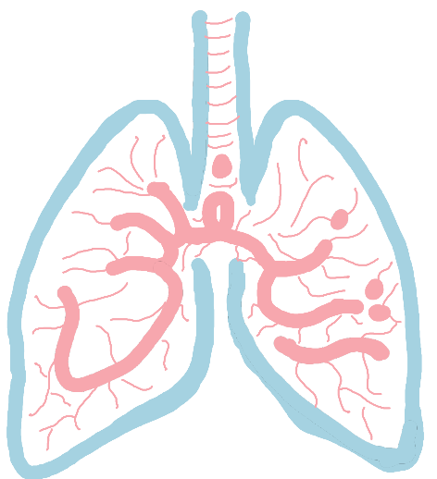
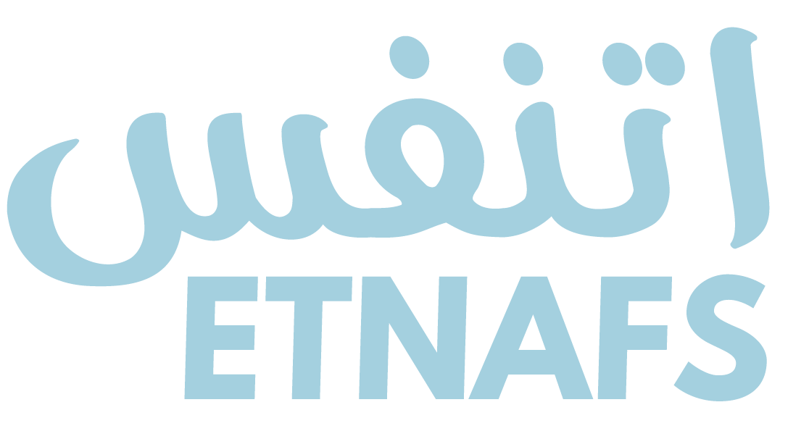
+2-011-23849195
EEV 20.1
ETNAFS@GMail.com
USER MANUAL

ETNAFS EMERGENCY VENTILATOR

EEV 20 ventilator

Parameters

- range 5 to 37 cm H2O adjustable in 1 cmH2O increment(+-0.001cmH2O)
- Monitor wirelessly over Wi-Fi network
- Air/Oxygen supply shouldn’t exceed 20 PSI
- Expiratory ratio (I:E) adjustable in the range 1.0 to 4.0 in 1 increment
- range 10 to 30 breaths per minute in increments of 1 (+-1breath)
- Tidal Volume (Vt) optionally Range 250 to 800 ml in steps of 10ml (+-30ml)
- 1 Hour rechargeable battery backup if power failure
- Oxygen percent control range 21% to 100% increments of 1% (+-2 %)
- The ability to input body weight and have volume calculated as, for example, 6ml/kg of ideal body weight

Alarms

- gas or electricity supply failure
- machine switched off while in mandatory ventilation mode
- inspiratory airway pressure exceeded
- inspiratory pressure not achieved (equivalent to disconnection alarm)
- tidal volume not achieved or exceeded

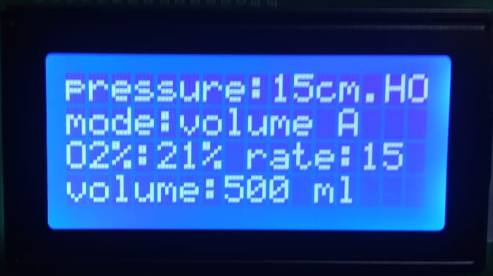

Monitoring

Modes
  - Continuous Positive Airway Pressure (CPAP)
  - Continuous Mandatory Ventilation (CMV)
  - Synchronous Intermittent Mandatory Ventilation (SIMV)
  - Airway Pressure Release Ventilation (APRV)
  - Pressure Support Ventilation (PSV)

Wireless monitoring
- Download ETNAFS android app from app store
- Scan the device QR code
- Monitor the device from your phone

Device control

Choose the parameter you want to change

Write the input

To change the mode just press on the mode button

To change the I:E ratio press on the I:E button

